Module 6.2 Assignment (Click Here To Submit Your Assignment)

Assignment: Movies: Setup
For this assignment, you will be learning how to create database tables, run SQL scripts from the terminal window to create tables, and how to connect a Python program to MySQL. There is a lot of information to absorb in this assignment. Make sure you take your time to understand what you are doing and why you are doing it.

1. Connecting Pycharm to MySQL
- The instructions for connecting to a database in PyCharm was in Module 4.
- Open up the PyCharm Install and Link to MySQL database document.

2. MySQL Examples used in the db_init.sql script
Open the db_init_2022.sql script in a text editor and you'll see how these examples are going to be used.
- MySQL: Drop User
  - DROP USER IF EXISTS <user_name>@<database_host>
  - Example
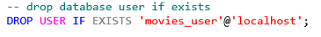
MySQL: Create User
  - CREATE USER <user_name>@<host> IDENTIFIED WITH mysql_native_password BY ;
  - Example
- MySQL: Grant User Privileges
  - GRANT ALL PRIVILEGES ON <database_name>.* TO <database_user>@<database_host>
  - Example
- MySQL: Drop Table
  - DROP TABLE IF EXISTS <table_name>;
  - Example

In this example, we are telling MySQL to delete the table studio if it already exists in the database. If the table studio does not exist, no action is invoked.

- MySQL: Create Table
  - CREATE TABLE <table_name> ( <field_values> );
  - Example:
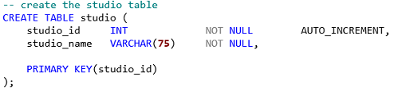
In this example, studio is the name of the table and studio_name is the column value. We don't include the _id field, since that auto-increments automatically.VARCHAR(75) is the data type for studio_name.

VARCHAR(75) represents the number of allowable characters in the string value. NOT NULL tells MySQL to not allow the insertion of null values. AUTO_INCREMENT tells MySQL to increment the studio_id by 1 each time a new record is inserted. PRIMARY KEY(studio_id) tells MySQL that studio_id is the table's primary key.
MySQL: Foreign Key Constraints
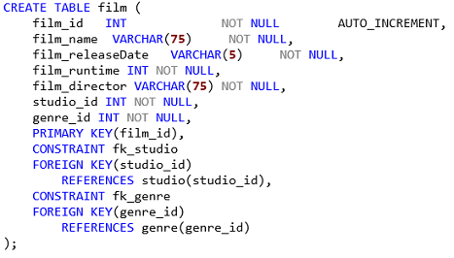
Foreign keys are how we represent one-to-many relationships. They are in fact, the mechanism for connecting related data sets. In this example, we add a new CONSTRAINT to the film table named fk_studio, which contains a FOREIGN KEY of studio_id. REFERENCES is used to tell MySQL that this foreign key connects to the studio table by studio_id.

- MySQL: Insert
  - INSERT INTO <table_name>( <fields_to_insert> ) VALUES ( <values_to_insert> );
  - Example

In this example, we are inserting a new record in the film table and mapping the values. The order you place the items in the VALUES section must match the order you have for the COLUMN VALUES. Remember, though, if the _id is auto-incremented, you do not include that in the VALUES list. Additionally, you'll see that to include the _id from studio and genre, I'm doing a SELECT to get the correct _id for for each type..

3. MySQL: CLI Scripts
- Start MySQL Command Line Client - Two ways
  - Log in to command line provided by MySQL. Or... If you click on 'Terminal' in the bottom menu bar in PyCharm, you've got some choices. On my machine Windows Powershell opens up by default. If you'd rather use the Command Prompt, click on the down arrow next to the '+' sign and select Command Prompt. You can also add a terminal for MySQL by clicking that '+' sign, adding another Command Prompt and then changing the directory to the bin of your MySQL server, on my machine it is: cd program files\mysql\mysql server 8.0\bin You can then use the following the connect to the MySQL Interface mysql -u root -p where root is the username you want to use. The -p means you will be prompted for a password.
  - Activate the desired database in the command line of your choice
    - use <database name> ;
    - Example: use movies;
- Run the SQL script
  - source <path_to_the_ sql_script>.sql
  - Example: source d:/CSD/csd_310/db_init_2022.sql
  - Note: the db_init_2022.sql script is attached to this assignment.
- Show a list of database tables (this assumes you have activated the database)
- Activate database: use <database name>;
  - USE movies;
- Show tables
  - SHOW TABLES;
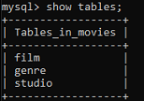
Just to make life more interesting, you can also run simple queries in PyCharm (if you are connected to the database) using a Query Console. In Pycharm, look at the items in the toolkit right below Database. You'll see what looks like QL in a box. Click on that, and open a console. Type in SHOW TABLES; click on the green 'play' button right above the console, and view the results.

4. MySQL: Python Script
First, make sure you have the mysql-connector-python driver installed. Then, open a text editor to create mysql_test.py.
- MySQL: Python Driver (pip)
  - pip install mysql-connector-python

- MySQL: mysql_test.py. Python imports needed
  - Import Statements
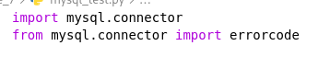
- MySQL: mysql_test.py.Database config object; use YOUR user (could be root, or the user created in the db_init_2022.sql file) and associated password
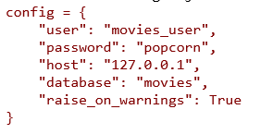
- MySQL: mysql_test.py. Connection test code
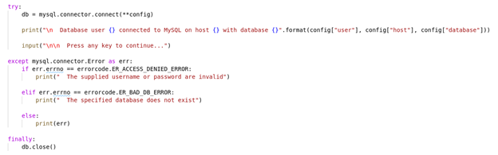
- Save your mysql_test.py.

5. Checklist
Be sure you have completed each of the following:
Reviewed the guide on how to activate a database.
Connected PyCharm to MySQL.
MySQL: Python Driver (pip).
MySQL: Python Connector Test.
MySQL: CLI Scripts.

6. Instructions
- Before proceeding any further, make sure you have completed the checklist.
- Start MySQL and activate the movies database.
- Run the db_init_2022.sql file.
  - Take a screenshot of the output from running that .sql file, and of the show tables command.
- Create a new directory under csd-310 and name it module_6.
- Under the module_6 directory, create a new file and name it mysql_test.py.
- Using the coding example I provided, create a new Python program that connects to the movies database.
  - Run the connect program, and take a screenshot of the output.
- Combine all images in a single word document and include your name, date, and assignment number.

7. GitHub
- Read through the GitHub tutorial at W3Schools. Basically this will be a three-step process. Add the files (stage), commit the files, then push the files.
- Stage, commit, and push your work to GitHub.

8. Deliverable
- Combine the images and your link to the GitHub repository into a single word document and include your name, date, and assignment.
- Save your document as <your-last-name>-<assignment-name> .docx.
- mysql_test.py

Assignment Requirements and Grading:
- This assignment is due by Sunday, 11:59 p.m., CST.
- Submit your assignment by clicking on the Assignment Link above, then scroll down to the Attach Files section and click on Browse Local Files. Select your assignment file, add any links or comments as appropriate, and then click on Submit.
- To view the rubric grading criteria, click on the following link: Programming Grading Rubric
(50 points)

config = {
'user': 'root',
'password': 'Cubswin!6',
'database': 'movies',
'raise_on_warnings': True
}

/**
* NAME: Wendy Rzechula
* DATE: June 30, 2023
* ASSIGNMENT NAME/NUMBER: Module 7 Assignment 1: Password Rules
* PURPOSE: Write a program that imposes certain rules for passwords.
* Write a method that checks whether a user's input String is a valid passwords.
*/

